Power Bank Holder

Version 1.0
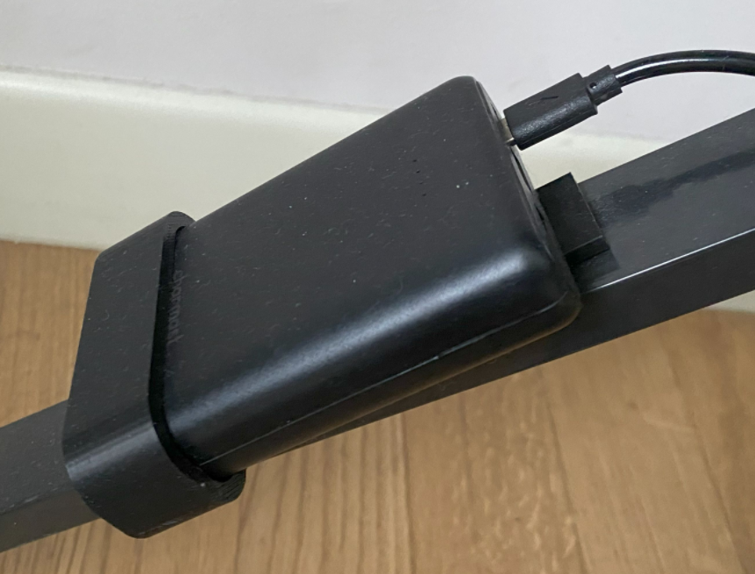

Project Goals
I need to power a portable keyboard (piano) using an external power source instead of internal AA batteries.
Since it requires just 12 Vdc I bought a USB-C to 12 Vdc converter / trigger that using the USB-C PD protocol force the power bank to generate 12 Vdc.
So now I need an holder to connect the power bank to the Piano support. And here it is the Power Bank Holder.

Power Bank Holder Sketch
This is the base sketch. The inner part is based on the power bank shape. See reference for more details on the power bank.

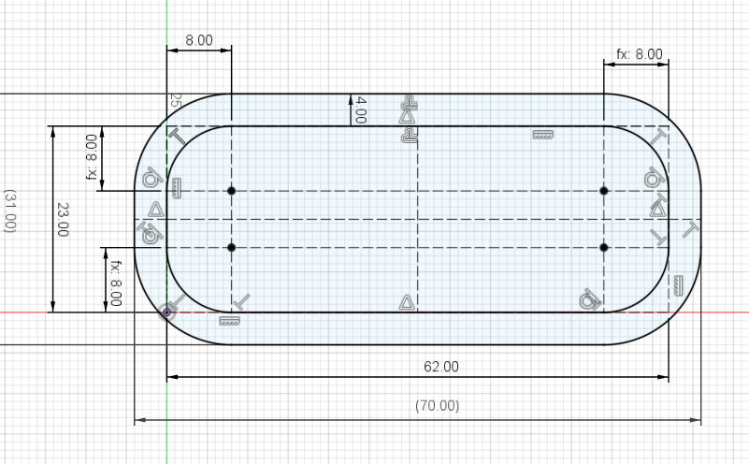
This is the back side and it is just 20x80 mm, 4 mm thick.
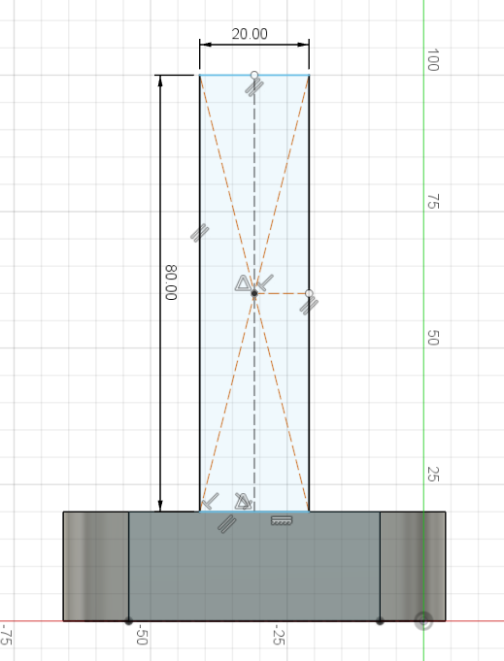

Power Bank Holder 3D Model
Base thickness: 20mm
Wall and back plane thickness: 4 mm

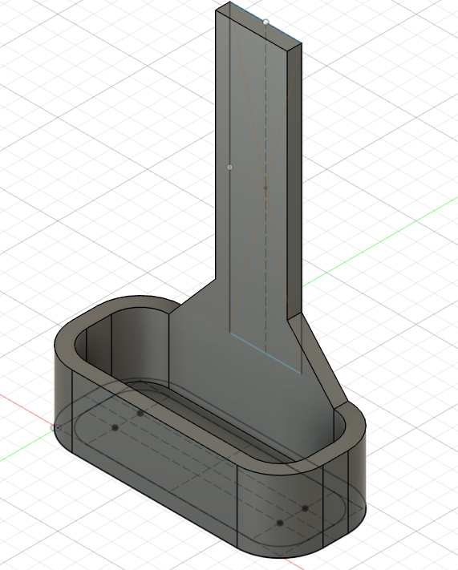

3D Printer layout
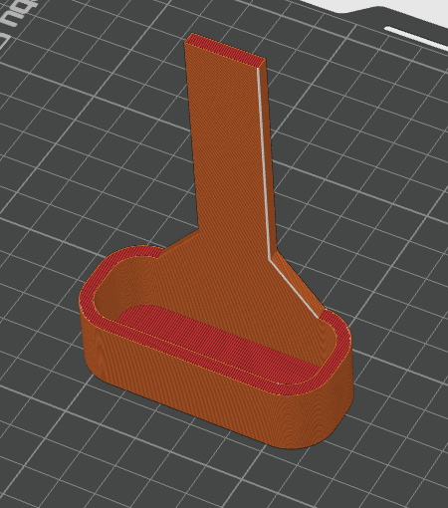

Final result
The object is linked to the metal frame using some double sided tape.
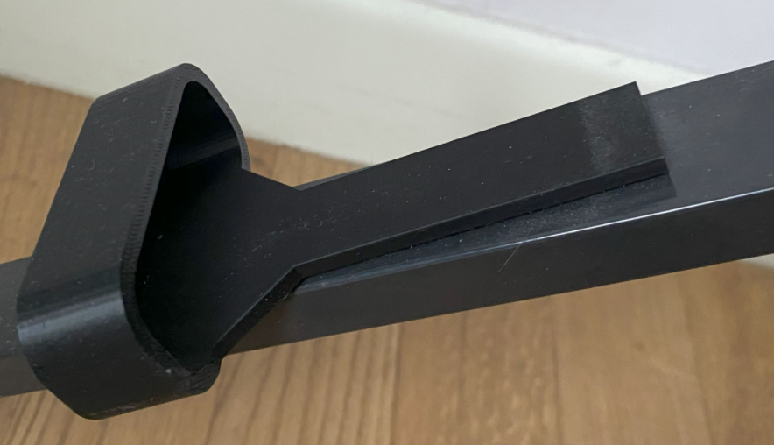 | 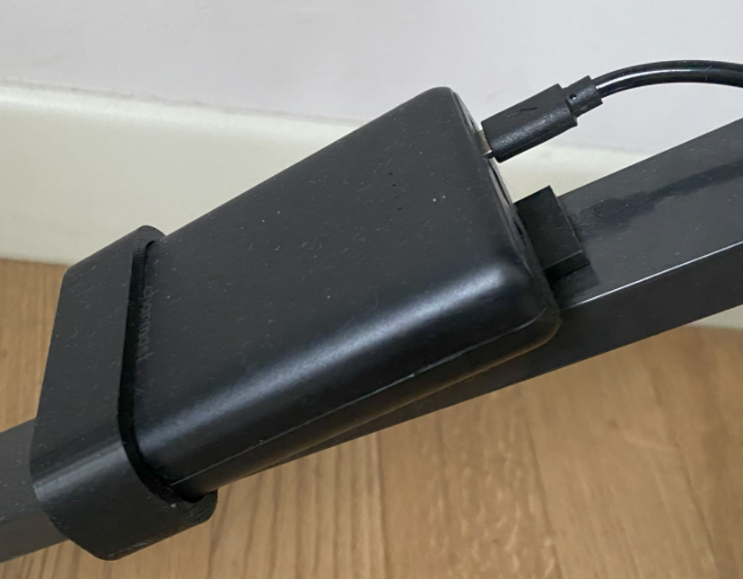

Reference

Charmast Power Bank 10Ah
https://amzn.eu/d/1koAXb7
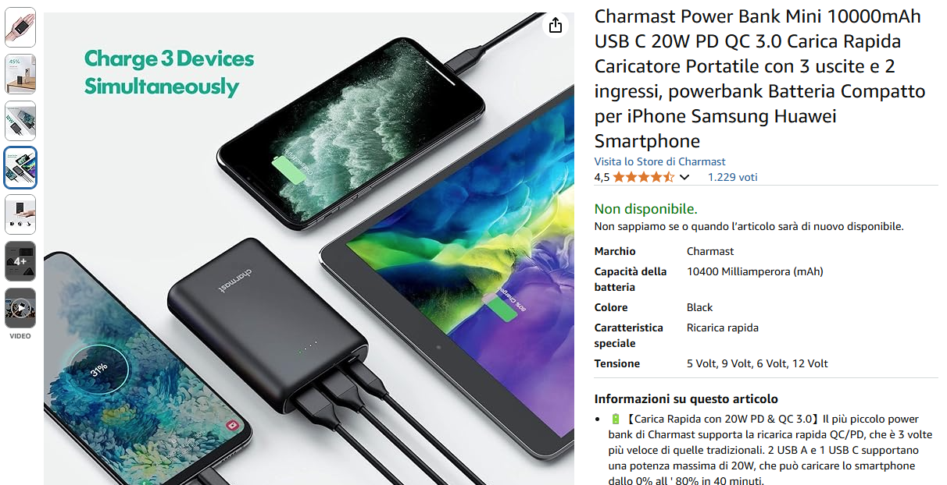

USB C to 12 Vdc converter
This is a possible converter from USB-C to 12 Vdc
https://amzn.eu/d/2KXkYtt
